**Batch: C3 Roll No.: 16010123217**

**Experiment No. 01**

|  |
| --- |
| **TITLE:** **Design the static web pages with the help of HTML5** |

**AIM:** To create static Web Pages using HTML5.

**______________________________________________________________________**

**Expected Outcome of Experiment:** Design static web pages using various HTML tags.

**_______________________________________________________________**

**Books/ Journals/ Websites referred:**

1. [w3schools](https://www.w3schools.com/Html/)

**_____________________________________________________________________**

The students are required to design Web Application using various technologies. A group of 2-3 students will select a topic and will design a web application. Various concepts such as static page, dynamic page, connection with a backend database are essential part of the application.

Students will be required to mention overall description of the problem (website facilities) to be provided by their application.

**Problem Statement:**

The online book store includes static web pages for seamless navigation and user interaction. The Home Page features frames for navigation and showcasing books. The Login Page allows user authentication, while the Catalogue Page displays book details in a sortable table. The Registration Page enables new user sign-ups with form validation. Consistent design and responsive layout ensure a user-friendly experience.

**Description of the application implemented with output**:

Home Page and Catalogue Page

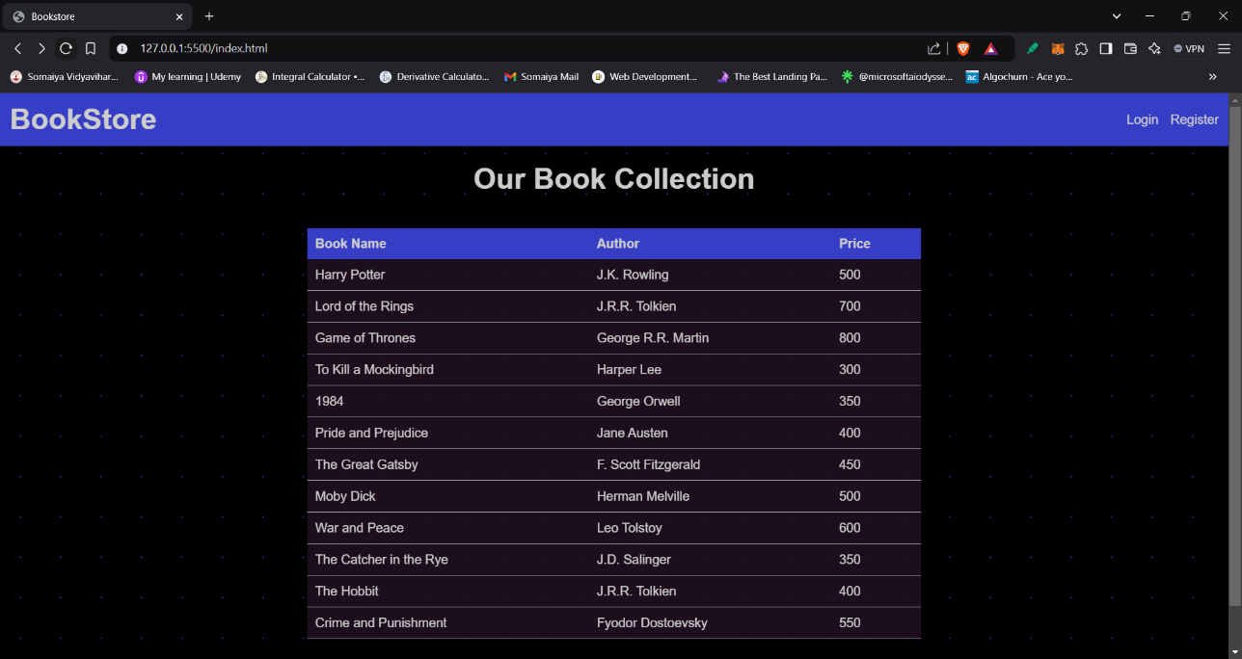

<!DOCTYPE html>

<html lang="en">

<head>

    <meta charset="UTF-8">

    <meta name="viewport" content="width=device-width, initial-scale=1.0">

    <title> Bookstore</title>

</head>

<body style="margin: 0; font-family: Arial, sans-serif; background-color: black;

opacity: 0.8;

background-image: radial-gradient(#444df7ad 1px, black 1px);

background-size: 50px 50px;">

    <nav style="background: #444df7; display: flex; justify-content: space-between; align-items: center; padding: 12px;">

        <div style="color: white; font-size: 36px; font-weight: bold;">

            <a href="index.html" style="color: white; text-decoration: none;">BookStore</a>

        </div>

        <ul style="display: flex; list-style: none; margin: 0; padding: 0;">

            <li style="margin-right: 15px;">

                <a href="login.html" style="color: #fff; text-decoration: none;">Login</a>

            </li>

            <li>

                <a href="register.html" style="color: #fff; text-decoration: none;">Register</a>

            </li>

        </ul>

    </nav>

    <h1 style="text-align: center; margin: 20px 0; color: #fff;font-size: 36px;">

        Our Book Collection

    </h1>

    <table style="margin: 40px auto; border-collapse: collapse; width: 50%; color: #fff; background-color: #231123;">

        <tr style="background: #444df7; color: #fff;">

            <th style="text-align: left; padding: 10px;">Book Name</th>

            <th style="text-align: left; padding: 10px;">Author</th>

            <th style="text-align: left; padding: 10px;">Price</th>

        </tr>

        <tr style="border-bottom: 1px solid #ccc;">

            <td style="padding: 10px;">Harry Potter</td>

            <td style="padding: 10px;">J.K. Rowling</td>

            <td style="padding: 10px;">500</td>

        </tr>

        <tr style="border-bottom: 1px solid #ccc;">

            <td style="padding: 10px;">Lord of the Rings</td>

            <td style="padding: 10px;">J.R.R. Tolkien</td>

            <td style="padding: 10px;">700</td>

        </tr>

        <tr style="border-bottom: 1px solid #ccc;">

            <td style="padding: 10px;">Game of Thrones</td>

            <td style="padding: 10px;">George R.R. Martin</td>

            <td style="padding: 10px;">800</td>

        </tr>

        <tr style="border-bottom: 1px solid #ccc;">

            <td style="padding: 10px;">To Kill a Mockingbird</td>

            <td style="padding: 10px;">Harper Lee</td>

            <td style="padding: 10px;">300</td>

        </tr>

        <tr style="border-bottom: 1px solid #ccc;">

            <td style="padding: 10px;">1984</td>

            <td style="padding: 10px;">George Orwell</td>

            <td style="padding: 10px;">350</td>

        </tr>

        <tr style="border-bottom: 1px solid #ccc;">

            <td style="padding: 10px;">Pride and Prejudice</td>

            <td style="padding: 10px;">Jane Austen</td>

            <td style="padding: 10px;">400</td>

        </tr>

        <tr style="border-bottom: 1px solid #ccc;">

            <td style="padding: 10px;">The Great Gatsby</td>

            <td style="padding: 10px;">F. Scott Fitzgerald</td>

            <td style="padding: 10px;">450</td>

        </tr>

        <tr style="border-bottom: 1px solid #ccc;">

            <td style="padding: 10px;">Moby Dick</td>

            <td style="padding: 10px;">Herman Melville</td>

            <td style="padding: 10px;">500</td>

        </tr>

        <tr style="border-bottom: 1px solid #ccc;">

            <td style="padding: 10px;">War and Peace</td>

            <td style="padding: 10px;">Leo Tolstoy</td>

            <td style="padding: 10px;">600</td>

        </tr>

        <tr style="border-bottom: 1px solid #ccc;">

            <td style="padding: 10px;">The Catcher in the Rye</td>

            <td style="padding: 10px;">J.D. Salinger</td>

            <td style="padding: 10px;">350</td>

        </tr>

        <tr style="border-bottom: 1px solid #ccc;">

            <td style="padding: 10px;">The Hobbit</td>

            <td style="padding: 10px;">J.R.R. Tolkien</td>

            <td style="padding: 10px;">400</td>

        </tr>

        <tr style="border-bottom: 1px solid #ccc;">

            <td style="padding: 10px;">Crime and Punishment</td>

            <td style="padding: 10px;">Fyodor Dostoevsky</td>

            <td style="padding: 10px;">550</td>

        </tr>

    </table>

    <div style="background-color: #444df7; color: white; text-align: center; padding: 10px; bottom: 0;">

        Made with ❤️ by Om Thanage

    </div>

</body>

</html>

Register Page:

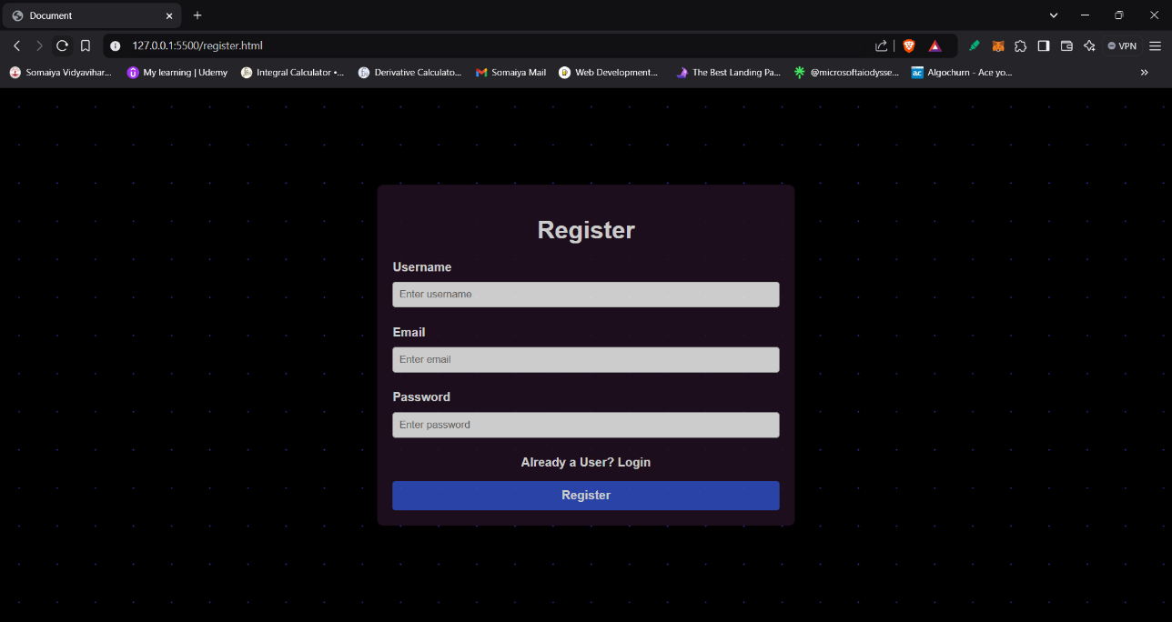

<!DOCTYPE html>

<html lang="en">

<head>

    <meta charset="UTF-8">

    <meta name="viewport" content="width=device-width, initial-scale=1.0">

    <title>Document</title>

</head>

<body style="font-family: Arial, sans-serif; margin: 0;

background-color: black;

opacity: 0.8;

background-image: radial-gradient(#444df7ad 1px, black 1px);

background-size: 50px 50px;

">

    <div style="display: flex; justify-content: center; align-items: center; height: 100vh; min-width: 400px;">

    <div style=" width: 33%; background: #231123; border-radius: 8px; color: white; padding: 20px;">

        <h1 style="text-align: center;">

            Register

        </h1>

        <form style="display: flex; flex-direction: column; font-weight: bolder;">

            <label for="username" style="margin-bottom: 10px;">Username</label>

            <input type="text" name="username" id="username" placeholder="Enter username" style="padding: 8px; margin-bottom: 5px; border-radius: 4px; border: 1px solid #ccc;" required>

            <br>

            <label for="username" style="margin-bottom: 10px;">Email</label>

            <input type="email" name="email" id="email" placeholder="Enter email" style="padding: 8px; margin-bottom: 5px; border-radius: 4px; border: 1px solid #ccc;" required>

            <br>

            <label for="password" style="margin-bottom: 10px;">Password</label>

            <input type="password" name="password" id="password" placeholder="Enter password" style="padding: 8px; margin-bottom: 5px; border-radius: 4px; border: 1px solid #ccc;" required>

            <br>

            <div style="margin-bottom: 15px; text-align: center;">

                Already a User? <a href="login.html" style="color: white; text-decoration: none; cursor: pointer;">Login</a>

            </div>

            <button type="submit" style="padding: 10px; background: #3454d1; color: #fff; border: none; border-radius: 4px; cursor: pointer;"><a href="login.html" style="color: white; text-decoration: none; cursor: pointer; font-weight: bold; font-size: 1rem;">Register</a></button>

        </form>

    </div>

    </div>

</body>

</html>

Login Page:

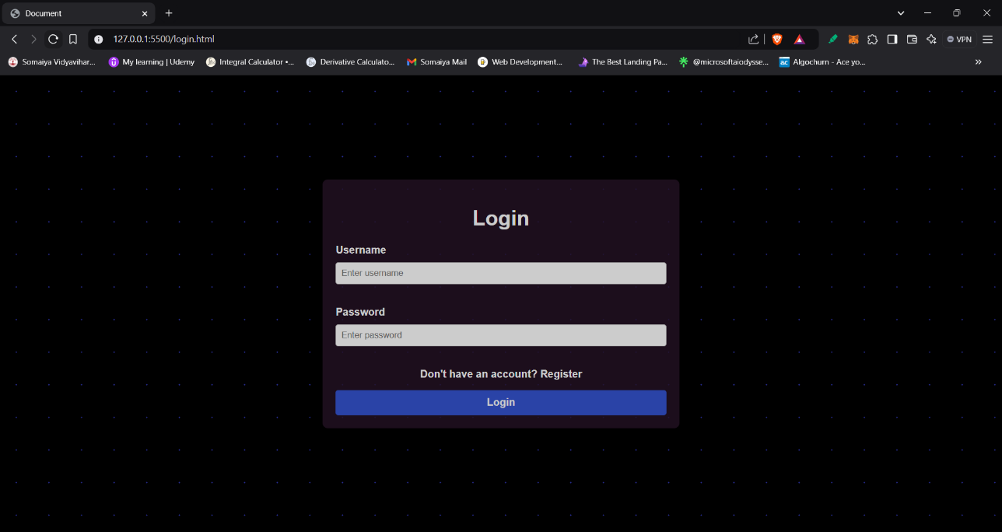

<!DOCTYPE html>

<html lang="en">

<head>

    <meta charset="UTF-8">

    <meta name="viewport" content="width=device-width, initial-scale=1.0">

    <title>Document</title>

</head>

<body style="font-family: Arial, sans-serif; margin: 0;

background-color: black;

opacity: 0.8;

background-image: radial-gradient(#444df7ad 1px, black 1px);

background-size: 50px 50px;">

<div style="display: flex; justify-content: center; align-items: center; height: 100vh; min-width: 400px;">

  <div style="width: 33%; background: #231123; border-radius: 8px; color: white; padding: 20px;">

    <h1 style="text-align: center;">

        Login

    </h1>

    <form style="display: flex; flex-direction: column; font-weight: bolder;">

        <label for="username" style="margin-bottom: 10px;">Username</label>

        <input type="text" name="username" id="username" placeholder="Enter username" style="padding: 8px; margin-bottom: 15px; border: 1px solid #ccc; border-radius: 4px;" required>

        <br>

        <label for="password" style="margin-bottom: 10px;">Password</label>

        <input type="password" name="password" id="password" placeholder="Enter password" style="padding: 8px; margin-bottom: 15px; border: 1px solid #ccc; border-radius: 4px;" required>

        <br>

        <div style="margin-bottom: 15px; text-align: center;">

            Don't have an account? <a href="register.html" style="color: white; text-decoration: none; cursor: pointer;">Register</a>

        </div>

        <button type="submit" style="padding: 10px; background: #3454d1; color: #fff; border: none; border-radius: 4px; cursor: pointer;"><a href="login.html" style="color: white; text-decoration: none; cursor: pointer; font-weight: bold; font-size: 1rem ;">Login</a></button>

    </form>

  </div>

</div>

</body>

</html>

**Post Lab Objective with Ans (Min 5):**

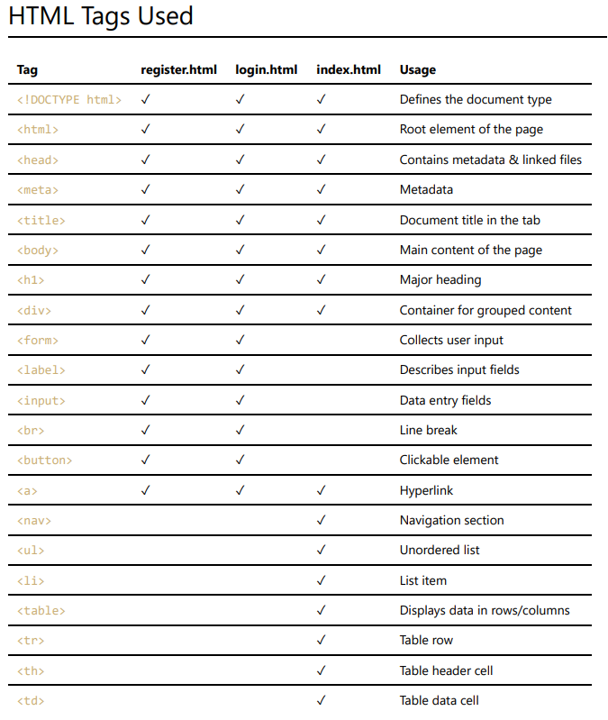

**B) Create a table to show your class timetable.**

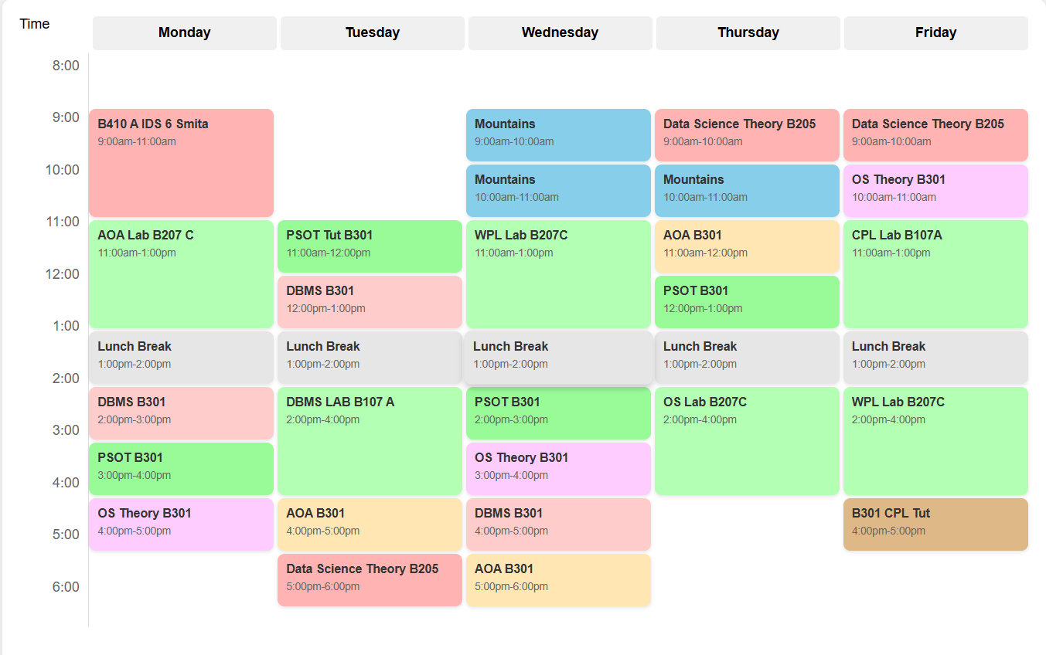

**Index.html**

<!DOCTYPE html>

<html lang="en">

<head>

    <meta charset="UTF-8">

    <meta name="viewport" content="width=device-width, initial-scale=1.0">

    <title>Weekly Schedule</title>

    <link rel="stylesheet" href="styles.css">

</head>

<body>

    <div class="schedule-container">

        <div class="header">

            <div class="time-column">Time</div>

            <div class="day-header">Monday</div>

            <div class="day-header">Tuesday</div>

            <div class="day-header">Wednesday</div>

            <div class="day-header">Thursday</div>

            <div class="day-header">Friday</div>

        </div>

        <div class="schedule-grid">

            <div class="time-column">

                <div class="time-slot">8:00</div>

                <div class="time-slot">9:00</div>

                <div class="time-slot">10:00</div>

                <div class="time-slot">11:00</div>

                <div class="time-slot">12:00</div>

                <div class="time-slot">1:00</div>

                <div class="time-slot">2:00</div>

                <div class="time-slot">3:00</div>

                <div class="time-slot">4:00</div>

                <div class="time-slot">5:00</div>

                <div class="time-slot">6:00</div>

            </div>

            <div class="schedule-content">

*<!-- Monday Events -->*

                <div class="event ids" style="grid-row: 2 / 4; grid-column: 1;">

                    <h3>B410 A IDS 6 Smita</h3>

                    <p>9:00am-11:00am</p>

                </div>

                <div class="event lab" style="grid-row: 4 / 6; grid-column: 1;">

                    <h3>AOA Lab B207 C</h3>

                    <p>11:00am-1:00pm</p>

                </div>

                <div class="event break" style="grid-row: 6 / 7; grid-column: 1;">

                    <h3>Lunch Break</h3>

                    <p>1:00pm-2:00pm</p>

                </div>

                <div class="event dbms" style="grid-row: 7 / 8; grid-column: 1;">

                    <h3>DBMS B301</h3>

                    <p>2:00pm-3:00pm</p>

                </div>

                <div class="event psot" style="grid-row: 8 / 9; grid-column: 1;">

                    <h3>PSOT  B301</h3>

                    <p>3:00pm-4:00pm</p>

                </div>

                <div class="event os" style="grid-row: 9 / 10; grid-column: 1;">

                    <h3>OS Theory B301</h3>

                    <p>4:00pm-5:00pm</p>

                </div>

*<!-- Tuesday Events -->*

                <div class="event psot" style="grid-row: 4 / 5; grid-column: 2;">

                    <h3>PSOT Tut B301</h3>

                    <p>11:00am-12:00pm</p>

                </div>

                <div class="event dbms" style="grid-row: 5 / 6; grid-column: 2;">

                    <h3>DBMS B301</h3>

                    <p>12:00pm-1:00pm</p>

                </div>

                <div class="event break" style="grid-row: 6 / 7; grid-column: 2;">

                    <h3>Lunch Break</h3>

                    <p>1:00pm-2:00pm</p>

                </div>

                <div class="event lab" style="grid-row: 7 / 9; grid-column: 2;">

                    <h3>DBMS LAB B107 A</h3>

                    <p>2:00pm-4:00pm</p>

                </div>

                <div class="event aoa" style="grid-row: 9 / 10; grid-column: 2;">

                    <h3>AOA B301</h3>

                    <p>4:00pm-5:00pm</p>

                </div>

                <div class="event theory" style="grid-row: 10 / 11; grid-column: 2;">

                    <h3>Data Science Theory B205</h3>

                    <p>5:00pm-6:00pm</p>

                </div>

*<!-- Wednesday Events -->*

                <div class="event mountains" style="grid-row: 2 / 3; grid-column: 3;">

                    <h3>Mountains</h3>

                    <p>9:00am-10:00am</p>

                </div>

                <div class="event mountains" style="grid-row: 3 / 4; grid-column: 3;">

                    <h3>Mountains</h3>

                    <p>10:00am-11:00am</p>

                </div>

                <div class="event lab" style="grid-row: 4 / 6; grid-column: 3;">

                    <h3>WPL Lab B207C</h3>

                    <p>11:00am-1:00pm</p>

                </div>

                <div class="event break" style="grid-row: 6 / 7; grid-column: 3;">

                    <h3>Lunch Break</h3>

                    <p>1:00pm-2:00pm</p>

                </div>

                <div class="event psot" style="grid-row: 7 / 8; grid-column: 3;">

                    <h3>PSOT  B301</h3>

                    <p>2:00pm-3:00pm</p>

                </div>

                <div class="event os" style="grid-row: 8 / 9; grid-column: 3;">

                    <h3>OS Theory B301</h3>

                    <p>3:00pm-4:00pm</p>

                </div>

                <div class="event dbms" style="grid-row: 9 / 10; grid-column: 3;">

                    <h3>DBMS B301</h3>

                    <p>4:00pm-5:00pm</p>

                </div>

                <div class="event aoa" style="grid-row: 10 / 11; grid-column: 3;">

                    <h3>AOA B301</h3>

                    <p>5:00pm-6:00pm</p>

                </div>

*<!-- Thursday Events -->*

                <div class="event theory" style="grid-row: 2 / 3; grid-column: 4;">

                    <h3>Data Science Theory B205</h3>

                    <p>9:00am-10:00am</p>

                </div>

                <div class="event mountains" style="grid-row: 3 / 4; grid-column: 4;">

                    <h3>Mountains</h3>

                    <p>10:00am-11:00am</p>

                </div>

                <div class="event aoa" style="grid-row: 4 / 5; grid-column: 4;">

                    <h3>AOA B301</h3>

                    <p>11:00am-12:00pm</p>

                </div>

                <div class="event psot" style="grid-row: 5 / 6; grid-column: 4;">

                    <h3>PSOT  B301</h3>

                    <p>12:00pm-1:00pm</p>

                </div>

                <div class="event break" style="grid-row: 6 / 7; grid-column: 4;">

                    <h3>Lunch Break</h3>

                    <p>1:00pm-2:00pm</p>

                </div>

                <div class="event lab" style="grid-row: 7 / 9; grid-column: 4;">

                    <h3>OS Lab B207C</h3>

                    <p>2:00pm-4:00pm</p>

                </div>

*<!-- Friday Events -->*

                <div class="event theory" style="grid-row: 2 / 3; grid-column: 5;">

                    <h3>Data Science Theory B205</h3>

                    <p>9:00am-10:00am</p>

                </div>

                <div class="event os" style="grid-row: 3 / 4; grid-column: 5;">

                    <h3>OS Theory B301</h3>

                    <p>10:00am-11:00am</p>

                </div>

                <div class="event lab" style="grid-row: 4 / 6; grid-column: 5;">

                    <h3>CPL Lab B107A</h3>

                    <p>11:00am-1:00pm</p>

                </div>

                <div class="event break" style="grid-row: 6 / 7; grid-column: 5;">

                    <h3>Lunch Break</h3>

                    <p>1:00pm-2:00pm</p>

                </div>

                <div class="event lab" style="grid-row: 7 / 9; grid-column: 5;">

                    <h3>WPL Lab B207C</h3>

                    <p>2:00pm-4:00pm</p>

                </div>

                <div class="event tutorial" style="grid-row: 9 / 10; grid-column: 5;">

                    <h3>B301 CPL Tut</h3>

                    <p>4:00pm-5:00pm</p>

                </div>

            </div>

        </div>

    </div>

</body>

</html>

**styles.css**

* {

    margin: 0;

    padding: 0;

    box-sizing: border-box;

}

body {

    font-family: Arial, sans-serif;

    padding: 20px;

    background-color: #f5f5f5;

}

.schedule-container {

    max-width: 1200px;

    margin: 0 auto;

    background-color: white;

    padding: 20px;

    border-radius: 10px;

    box-shadow: 0 0 10px rgba(0,0,0,0.1);

}

.header {

    display: grid;

    grid-template-columns: 80px repeat(5, 1fr);

    gap: 4px;

    margin-bottom: 4px;

}

.day-header {

    background-color: #f0f0f0;

    padding: 10px;

    text-align: center;

    font-weight: bold;

    border-radius: 5px;

}

.schedule-grid {

    display: flex;

}

.time-column {

    width: 80px;

    flex-shrink: 0;

}

.time-slot {

    height: 60px;

    padding: 5px;

    border-right: 1px solid #ddd;

    text-align: right;

    padding-right: 10px;

    color: #666;

}

.schedule-content {

    flex-grow: 1;

    display: grid;

    grid-template-columns: repeat(5, 1fr);

    grid-template-rows: repeat(11, 60px);

    gap: 4px;

    position: relative;

}

.event {

    padding: 10px;

    border-radius: 8px;

    overflow: hidden;

    cursor: pointer;

    transition: transform 0.2s;

    box-shadow: 0 2px 4px rgba(0,0,0,0.1);

}

.event:hover {

    transform: scale(1.02);

    box-shadow: 0 4px 8px rgba(0,0,0,0.2);

}

.event h3 {

    font-size: 14px;

    margin-bottom: 5px;

    color: #333;

}

.event p {

    font-size: 12px;

    color: #666;

}

*/* Event type colors */*

.ids { background-color: #ffb3b3; }

.lab { background-color: #b3ffb3; }

.break { background-color: #e6e6e6; }

.dbms { background-color: #ffcccc; }

.psot { background-color: #98FB98; }

.os { background-color: #ffccff; }

.aoa { background-color: #ffe6b3; }

.theory { background-color: #ffb3b3; }

.mountains { background-color: #87CEEB; }

.tutorial { background-color: #DEB887; }

@media (max-width: 768px) {

    .schedule-container {

        padding: 10px;

    }

    .event h3 {

        font-size: 12px;

    }

    .event p {

        font-size: 10px;

    }

}